**Project Proposal**

**Project relevance**

Time is an essential and finite resource for everyone. Throughout history people relied on natural signs for managing their schedules. However, in recent times scheduling has separated from natural signs. And as the world grows and evolves, the need for efficient time management grows exponentially. As Ayşegül AYDIN et al. (2017) mentioned in their research, time management has it’s influence on academic performance, forming of social groups. It also affects the amount of free time one has. Therefore, time management should be held as high priority.

Yangyang Fu1 et al. (2025) have stated that time management might indirectly increase one’s engagement in their jobs and mundane tasks. Another influence of time management outlined in the study is that it increases self-control and reduces addictions, namely mobile phone addiction. Which increases demand for time management, as nearly 70% of people struggle with mobile phone addiction as mentioned by Wen Xiao et al. (2022).

The model of a free To-Do list management service with paid account option, that allows saving data across devices fits the current market trends, offers customer attraction and allows for a sustainable profit generation. This model would attract customers with a free time management tool, while narratively push them toward a paid subscription or a one-time purchase that would allow them to sync their data across devices.

**Analysis**

We based our idea on multiple services that allow people to keep track of their tasks. They are very popular due to the nature of today, that makes time management a necessity. We analyzed three services: [Any.do](https://www.any.do/), [Todoist](https://www.todoist.com/), [Microsoft To-Do](https://to-do.office.com/tasks/today).

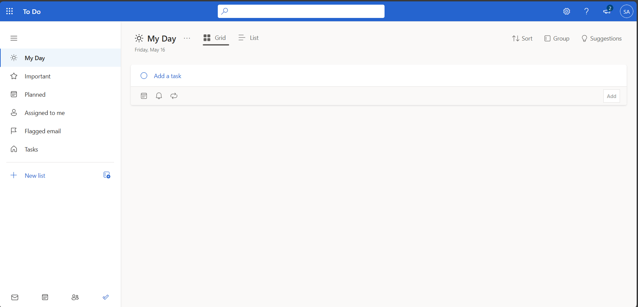

1. Microsoft To-Do "My Day" Page

Microsoft To-Do provides a free task scheduling service with paid features for corporate users.

Microsoft To-Do is popular for its integration with Microsoft suite. It is very handy for corporate groups, where scheduling also needs to integrate with meetings, chats, documents.

Another platform we analyzed is Todoist. This tool provides basic scheduling as a free service, and as a paid subscription sells a suite of personalization, backups and sync.

. Todoist "Today" Page

Next service is Any.do. Any.do provides basic scheduling service for free with automation, messaging integration and customization as a paid premium. It features a simple user-friendly interface with a bright theme.

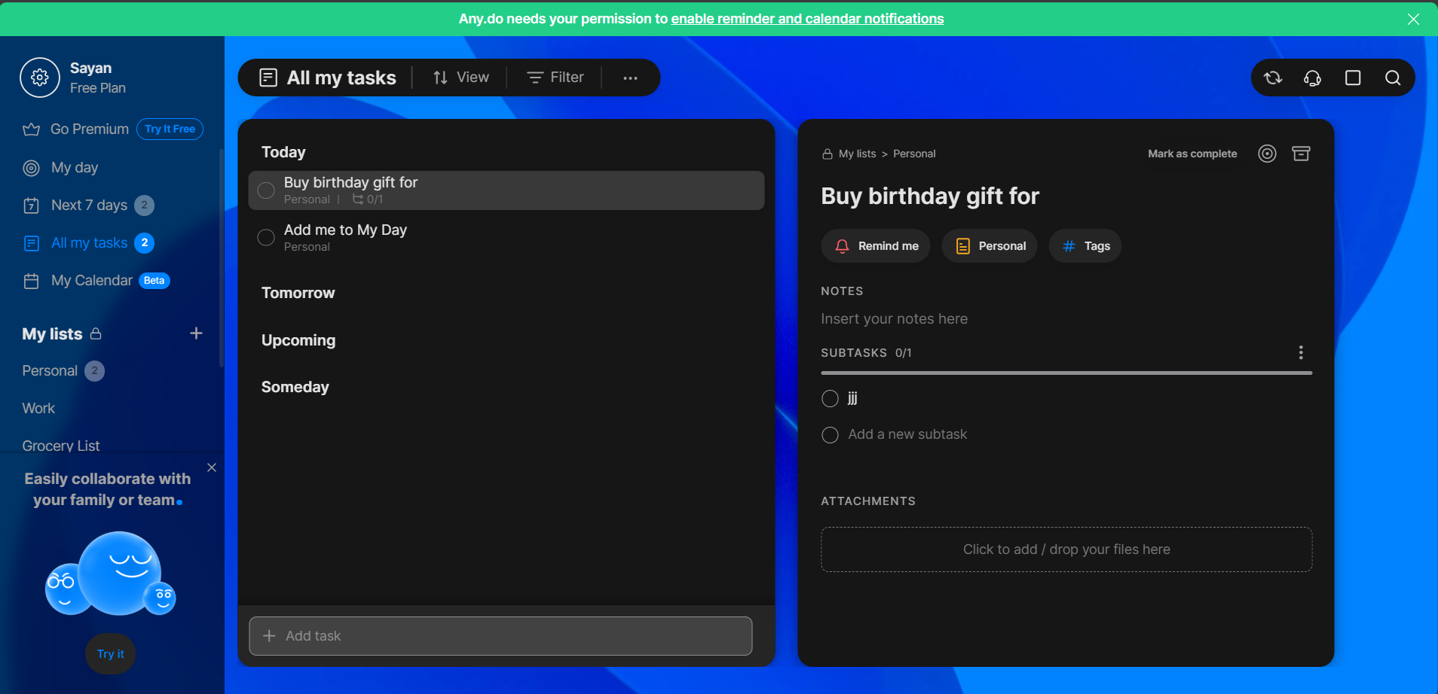

. Any.do "All my tasks" page

All of the reviewed tools feature following pages:

* My day: tasks set for the current day
* Upcoming or Planned: Tasks scheduled for the nearest several days
* Notifications: Page for service messages and reminders
* Task creation: Form for creation of new tasks. Sometimes a pop-up window

The analysis has also shown that the platforms use the following model: they provide basic scheduling service for free, and allow optional paid features like automation, backups, etc.

**Project auditory**

The application for time management with a free tier basic functionality implies attraction of the following social groups: working adults, high school and university students. This platform will provide users with a simple to use interface and flexible solutions while maintaining sustainability.

**Research of auditory**

To reinforce our model, we conducted an independent questionnaire on the public, where the respondents were asked about features and financial model.

The questionnaire link:   
<https://docs.google.com/forms/d/e/1FAIpQLSfGFTyv77Qkc-lVX4glku62SannNE127NthSJn_mB_UBHKpQg/viewform?usp=header>

The research concluded that most of respondents have had experiences with planning apps. This is a valuable insight, it shows that our respondents already rely on tools to plan their tasks.

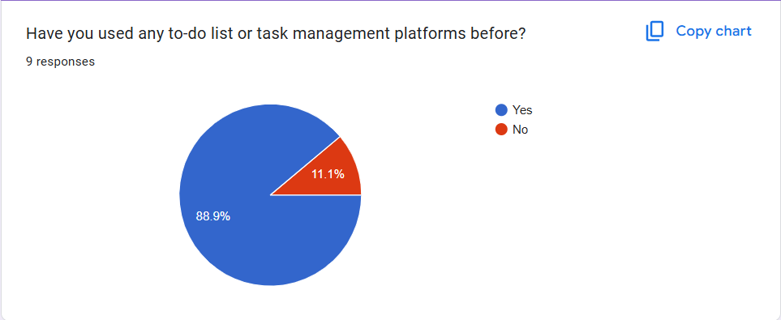

Our respondents have also shown interest in the following features:

This shows that the most important is task management itself, and subtasks and collaboration being the next most needed features.

We also found out that our target audience agrees with “freemium” model and is willing to pay for certain features.

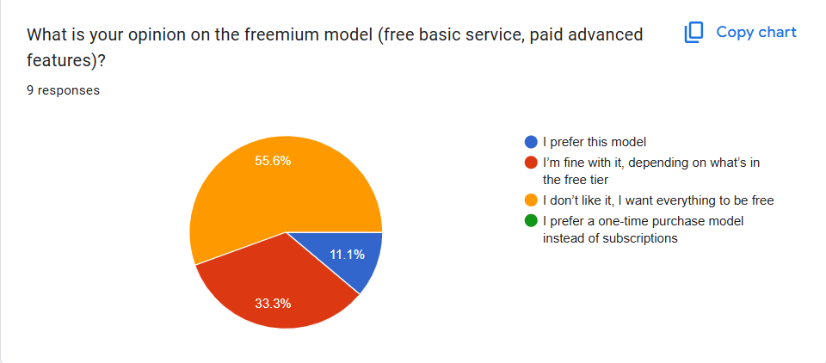

**Project features**

To-Do list website: Building a user-friendly website for setting, viewing and updating tasks.

Key features: Creation, deletion, updating, viewing tasks. Notifications page for tasks and platform related notifications, tasks statistics and analytics. Simple non-bloated interface.

Financial model: “Freemium” – a model where a certain set of features is accessible for free for anyone, and a wider functional is delivered for subscribed users.

**References**

Aydın, A., Ünalan, D., & Somunoğlu İkinci, S. (2017). THE EFFECT OF TIME MANAGEMENT ON THE ACADEMIC ACHIEVEMENTS OF UNIVERSITY STUDENTS. International Journal of Social And Humanities Sciences, 1(2), 39-53.

*Fu, Y., Wang, Q., Wang, X. et al. Unlocking academic success: the impact of time management on college students’ study engagement. BMC Psychol****13****, 323 (2025).* [*https://doi.org/10.1186/s40359-025-02619-x*](https://doi.org/10.1186/s40359-025-02619-x)

Xiao W, Wu J, Yip J, Shi Q, Peng L, Lei QE, Ren Z  
The Relationship Between Physical Activity and Mobile Phone Addiction Among Adolescents and Young Adults: Systematic Review and Meta-analysis of Observational Studies  
JMIR Public Health Surveill 2022;8(12):e41606  
<https://doi.org/10.2196/41606>

Any.do: <https://app.any.do/>   
Todoist: <https://app.todoist.com/>  
Microsoft To-Do (WEB version): <https://to-do.office.com/>